**-: Lab assignment-2 :-**

1.)create table , name:client_master

|  |  |  |
| --- | --- | --- |
| **Column name** | **Data type** | **size** |
| Client-no | Varchar2 | 6 |
| name | Varchar2 | 20 |
| Address1 | Varchar2 | 30 |
| Address2 | Varchar2 | 30 |
| city | Varchar2 | 15 |
| pincode | number | 8 |
| State | Varchar2 | 15 |
| Bal_due | number | 10,2 |

**Output:-**

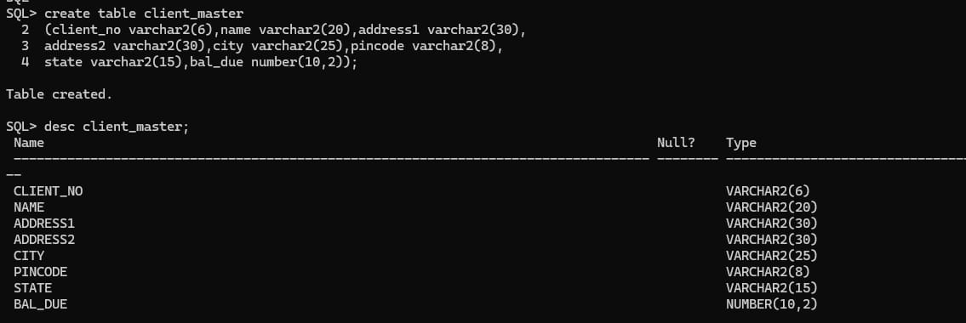

2.create table ,name:product_master.

|  |  |  |
| --- | --- | --- |
| Column nmae | Data type | size |
| Product_no | Varchar2 | 6 |
| description | Varchar2 | 15 |
| Profit_perecent | number | 4,2 |
| Unit_mesure | Varchar2 | 10 |
| Qty_on_hand | number | 8 |
| Record_lvl | number | 8 |
| Sell_price | number | 8,2 |
| Cost_price | number | 8,2 |

**Output:-**

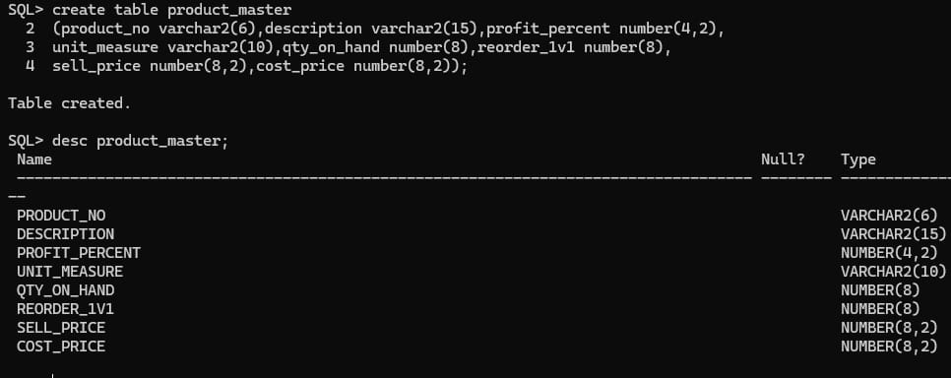

3.)create table,name:salesman_master.

|  |  |  |
| --- | --- | --- |
| Column_name | Data type | size |
| Salesman_no | Varchar2 | 6 |
| Salesman_name | Varchar2 | 20 |
| Address1 | Varchar2 | 30 |
| Address2 | Varchar2 | 30 |
| city | Varchar2 | 20 |
| pincode | number | 8 |
| state | Varchar2 | 20 |
| Sal_amt | number | 8,2 |
| Tgt_to_get | number | 6,2 |
| Ytd_sales | number | 6,2 |
| Remark | Varchar2 | 60 |
|  |  |  |

**Output:-**

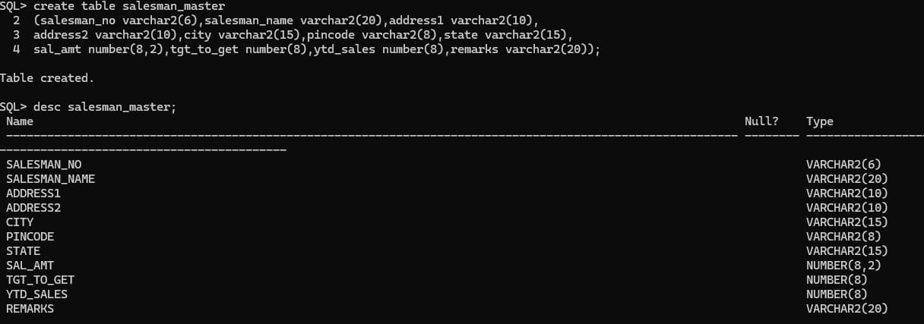

1.insert into :client_master.

**Output:**

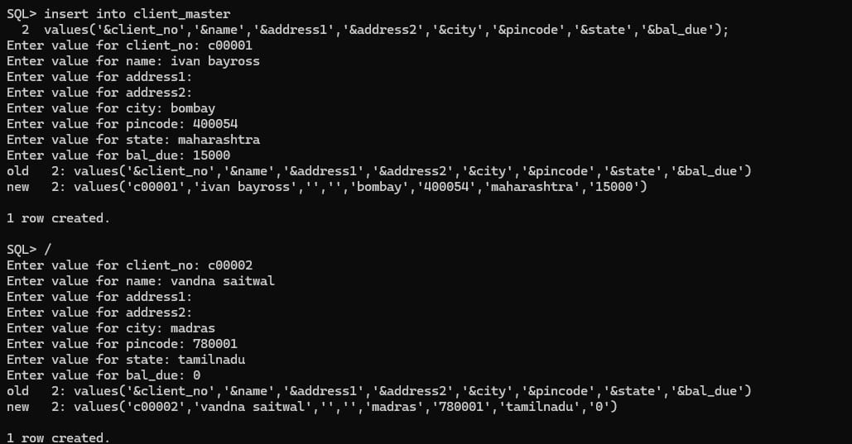

2.insert into :product_master.

**Output:**

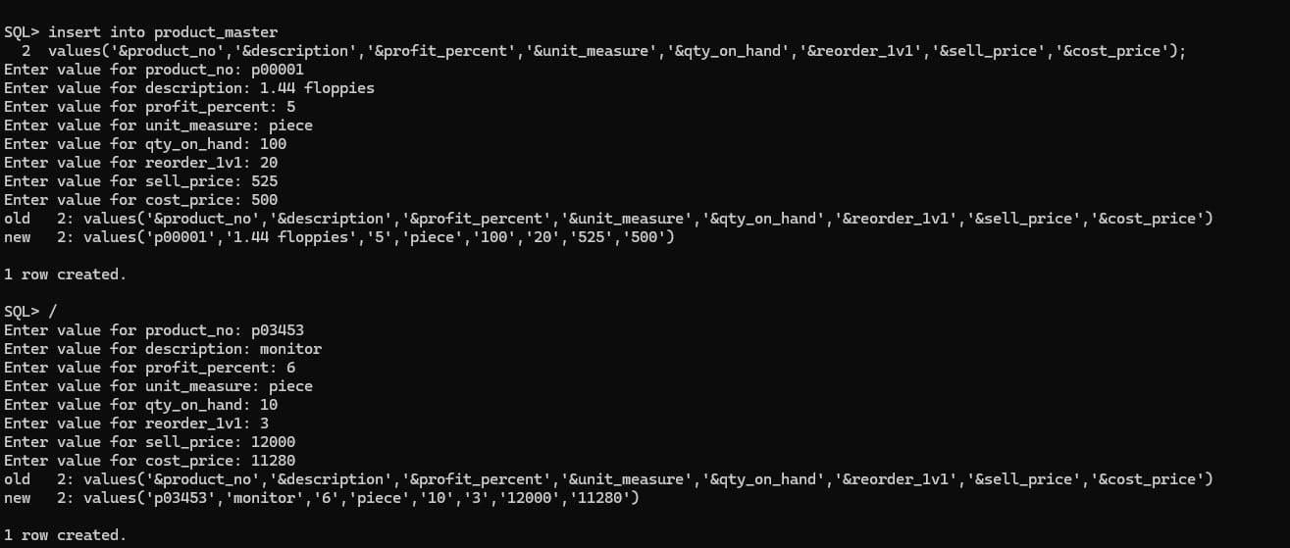

3.insert into :salesman_master.

**Output:**

